ADC online
Biography of the experts of the week 1

Dr. Victor Niţă
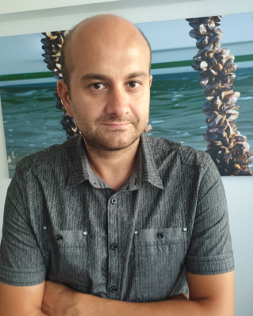
Dr. VICTOR NIŢĂ, 37, male, is a biologist, senior researcher and Head of Marine Living Resources Department within the National Institute for Marine Research and Development “Grigore Antipa” Constanta, Romania.
- He holds a PhD in Aquaculture, Master in Biodiversity Conservation and Environmental Protection, University Degree in Biology.
- He is member of NIMRD’s Scientific Council and of the editorial board of the “Marine Research” journal.
- He is scientific referee of the journals “Aquaculture, Aquarium, Conservation & Legislation” and “Advances in Environmental Sciences”.
- He coordinates the Aquaculture Laboratory of NIMRD Constanta and is the executive director of the FAO – GFCM Shellfish Aquaculture Demonstrative Centre, as a regional hub able to respond to Black Sea countries needs and expectations for aquaculture development and to launch aquaculture pilot projects.
- He has 14 years of experience in various national and international research projects (as coordinator and/or team member), such as Nucleu Program, PN II, FP7, Horizon 2020, BSB-CBC, ERA-NET, EASME-EMFF, POS-Mediu, POIM.
His main research concerns include:
- Aquaculture experiments using Recirculating System Technology for finfish (on species like: turbot, sturgeons, mullets, etc.).
- Development of shellfish aquaculture framework in Black Sea riparian countries; management and investigations of Marine Protected Areas and biodiversity (acting as head custodian of the Vama Veche – 2 Mai marine reserve).
Valeria Abaza
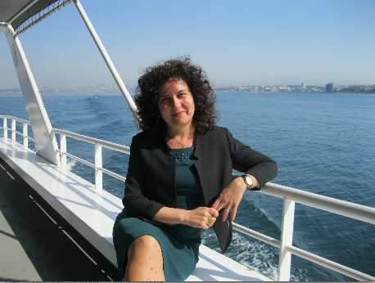
Valeria Abaza is a marine biologist, PhD, for the National Institute for Marine Research and Development “Grigore Antipa”, Constanta, Romani. After working for more than 25 years in the field of marine ecology, her areas of interest include:
- Assessment of the ecological status of marine benthic communities from the Black Sea coastal Romanian waters under anthropogenic influence.
- Assessment of the mussel’s stocks from the Romanian Black Sea shelf and their bio-productive potential in the coastal epibiotic systems.
- Study of the impact of different economic activities on the marine zoobenthic communities.
- Ecology and biodiversity of marine benthic communities under present environmental conditions, coordinating and participating as team member in different national and international projects.
- Expert in the implementation of EU Water Framework Directive: coordination of the study regarding the elaboration of methodologies for the ecological assessment of biological quality elements (BQEs) for the marine water bodies; zoobenthos expert in the GIG WFD inter-calibration with Bulgaria.
- Expert in implementation of the Marine Strategy Framework Directive, D1 – biodiversity (benthic communities and benthic habitats) and D6 – seafloor integrity and related indicators
- Elaboration of the national annual reports concerning the marine biodiversity status.
- National expert in the elaboration of the Black Sea Strategic Action Plan (2009).
- Expert in elaboration of the National Strategy and Action Plan for Biodiversity Conservation (2010)
- National Focal Point for the Conservation of Marine Biodiversity, member of the Advisory Group on Biodiversity Conservation (AG CBD) of the Commission on the Protection of the Black Sea Against Pollution (known as Black Sea Commission)(2004-2011).
Between 2011 and 2014 working as pollution monitoring and assessment officer (PMA officer) of the Black Sea Commission Permanent Secretariat (Istanbul, Turkey) she had the following responsibilities:
- Coordination of the six Advisory Groups’ activities; among them coordination of the Advisory Group on Biodiversity Conservation working on biodiversity indicators, Black Sea Habitats List and Strategic Action Plan for the implementation of the Black Sea Biodiversity and Landscape Conservation Protocol.
- Compilation and elaboration of the annual reports regarding the state of the Black Sea environment and implementation of the Black Sea Strategic Action Plan (2009).
- Coordination of the regional Black Sea integrated monitoring and assessment programme.
- Coordination of the collaboration of the Black Sea Commission with the international partner organizations on the protection of the Black Sea environment.
- Coordination of implementation of the programme for data quality assurance from the marine monitoring programmes.
- Management of the projects implemented by the Permanent Secretariat of the Black Sea Commission.
- Member of the Advisory Board of the EU FP7 projects ODEMM, CoCoNET, DEVOTES, and DG-ENV project MISIS.

Daniela Roşioru
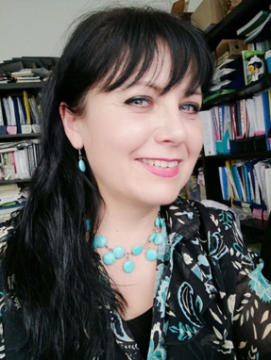
Daniela Rosiour has a PhD in biochemistry and is a senior researcher and Head of the Marine Biochemistry and Eco-physiology Laboratory, Department of Ecology and Marine Biology at the National Institute for Marine Research and Development "Grigore Antipa”, Constanta, Romania. Her main activities and responsibilities include:
- Coordinator of the Marine Biochemistry and Eco-physiology Laboratory from 2007 to present.
- Marine biochemistry (composition, enzymology, food value).
- Biotechnological valuation of marine resources for medical and pharmaceutical purposes.
- Standardization, testing and validation of new methods for determining the nutritional value of marine organisms within the accreditation process of the Marine Biochemistry and Eco-physiology Laboratory according to SR ISO 17025, ISO 9001.
- Environmental impact assessment.
Her previous work experience includes:
- Collaboration in over 40 projects and research contracts (national and international).
- Over 70 scientific papers published in recognized international and national specialty journals.
- Over 100 presentations at national and international symposiums, conferences, congresses, recognized workshops and seminars.
- Coordinating over 20 projects and research contracts (national and international):
- Contract MM: 8677/14.10.2009 - Study on the assessment of the quality compliance of the water quality for molluscs from the Romanian seaside with the specific quality objectives stipulated by the national and EU legislation; identifying causes of non-compliance and mitigation measures (2009).
- Project: PN 09 32 02 05: Influence of environmental factors on eco-physiological status of molluscs of commercial interest on the Romanian seaside (2009-2015).
- Contract MMP no. 55/23.06.2011- Study on monitoring of waters and sediments in the areas designated for the harvest / breeding of molluscs (2011).
- Contract CO14-11/11.11.2014- Monitoring of waters and sediments in the areas designated for the harvesting/growing of molluscs (Directive 79/923 / EC on the quality of waters for mollusks.
- PN16230302 - Research on biotechnological valuation of certain living marine resources in the Romanian Black Sea sector (2016-2017).
- Complex Project no. 85PCCDI/2018-2021- Complex valuation of marine bio resources by developing and applying innovative and emergency biotechnologies (INOBIOMAR ).

PhD Candidate Oana Vlas
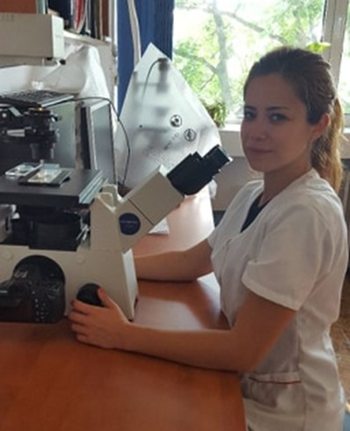
Working at the National Institute of Marine Research and Development Grigore Antipa as a Research Assistant in biology, in the Ecology and Marine Biology Department since 2013. Professional background:
- phytoplankton composition and distribution in the Romanian marine waters;
- microalgae cultures;
- ecotoxicology experiments; sampling and microscopically identification of phytoplankton species;
- process and manage phytoplankton data; evaluation of eutrophication impact on marine ecosystem;
- monitoring of marine water quality according to WFD and MSFD.

Dr. Eng. Simion Nicolaev
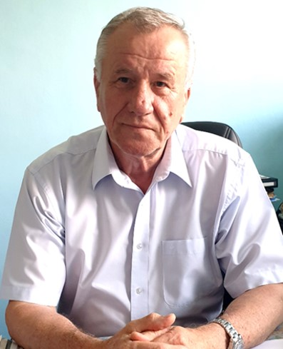
General Director of the National Institute for Marine Research and Development “Grigore Antipa” Constanta, Romania, since 1990. He has a Ph.D. in Marine Fishery from the “Lower Danube” University Galati, Romania.
- Chairman of National Oceanographic Committee (IOC/UNESCO);
- Chair of Advisory Group on Environmental Aspects of Fisheries and Management of other Marine Living Resources (Black Sea Commission);
- Responsible of Technical Permanent Secretariat of the National Committee of the Coastal Zone;
- Member of ACCOBAMS Bureau (2002-2011); Member of the Danube Delta Biosphere Reserve Scientific Council; National Expert in IOC Advisory Body of Experts on the Law of Sea (1996-2000);
- National Expert in IOC Advisory Body of Experts on the Law of Sea;
- Coordinator of the Working Group for the Black Sea/General Fisheries Commission for the Mediterranean;
- member in Advisory Board for Research and Innovation of Ministry of Research and Innovation;
- Member in Commission for fishery and aquaculture of the Agriculture and Forestry Science Academy;
- Director of Regional Activity Centre for Black Sea Fisheries (BSEP).
- Associated Professor of the “Ovidius” University, Constanta - Integrated Coastal Zone Management Master Programme.

